NAME: ___________________________________ YEAR: _________
__________________________________________________________________

ENGLISH
YEAR 3

TERM 1
Compiled by L Papp

TERM 1

DATE: ____________________________ TOPIC: COMMUNICATION (WEEK 1)
___________________________________________________________________
ACTIVITY 1 LISTENING & SPEAKING
DISCUSSION: What is communication?
Content
The learner is able to:
- Understand and use new vocabulary
- Take part in discussion
- Give own opinion
- Answer questions

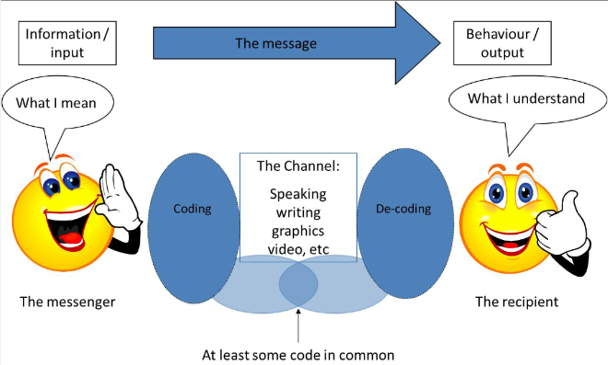
New vocabulary.
- Sender | The person who sends the message (Communicates)
- Receiver | The person who receives the message
- Decode | Understand the message
- Respond | Say something back / send a message back

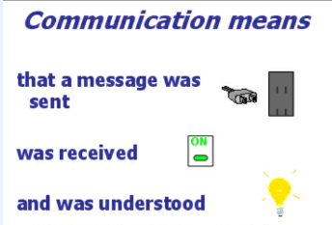
Decode
Send a message back
(2 way process)

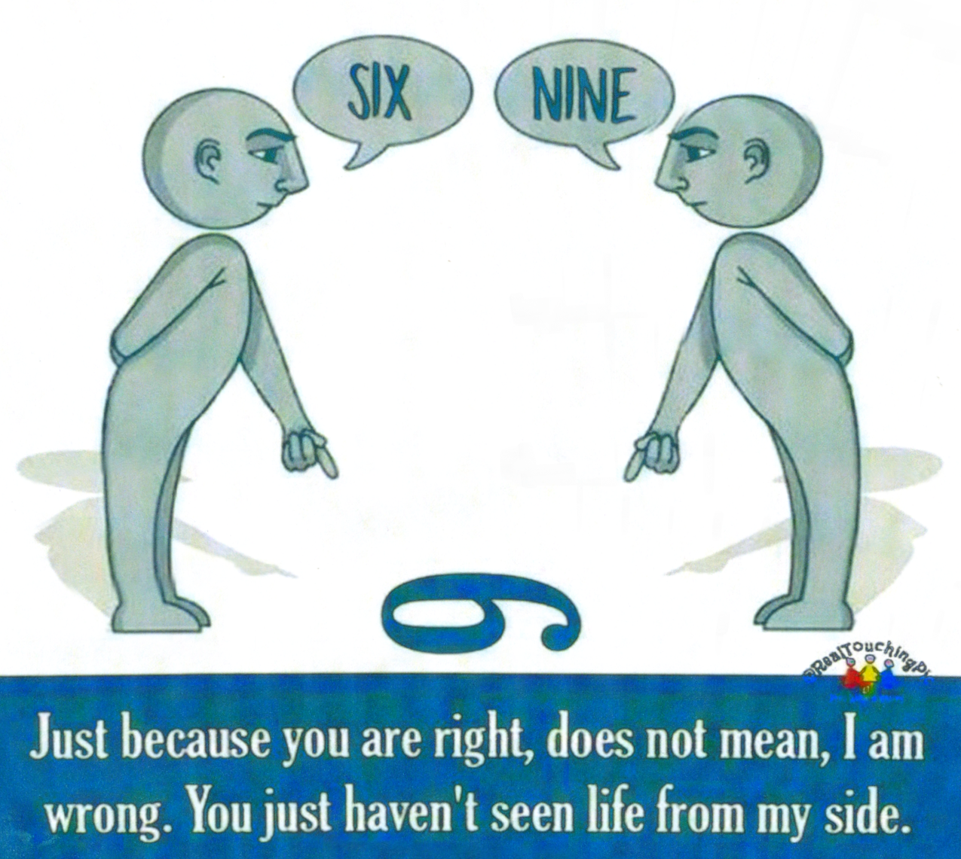
Look at the following illustration. Take part in a conversation that your teacher will initiate on how communication can cause confusion among speakers. Name a few factors that can contribute to misunderstanding of each other.

DATE: ____________________________ TOPIC: COMMUNICATION (WEEK 1)
___________________________________________________________________
ACTIVITY 2 READING & VIEWING

Content
The learner is able to:
- Take part in shared reading
- Apply individual reading

2.1 What is communication?
Communication means
- that a message was sent
- was received
- was understood

We respond based on:
- what we think we have heard
- our background and
- our beliefs.

However, when we communicate, words are only part of the story. We also use body language and tone of voice to communicate.

2.2 Three parts of communication

Body Language 55%

A Words

Words make up a mere 7% of communication. However, if we do not know what the words mean, there is no way that we can communicate successfully.

B Tone of voice

Tone of voice is how we say something, compare for example:

- THIS is mine
- This IS mine
- This is MINE

C Body Language

Body language is the way we use our bodies to communicate, for example rolling our eyes, using our hands and even the way we stand. It is important to keep our body language positive. Some examples of positive body language are:

- Making eye contact
- Keeping our hands open as opposed to clenched
- Smiling
- Standing up straight
- Leaning towards the person we are listening to
- Turning our head slightly towards the person talking.

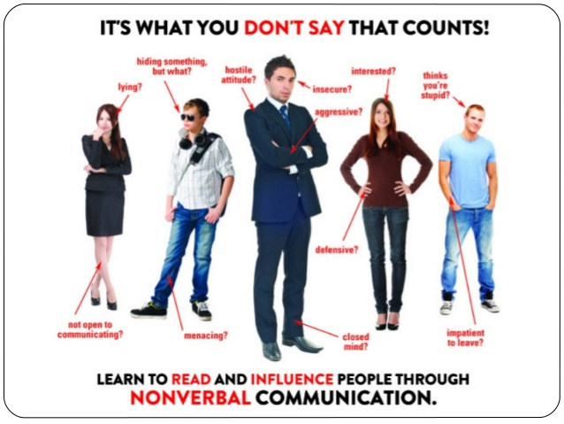

Positive body language

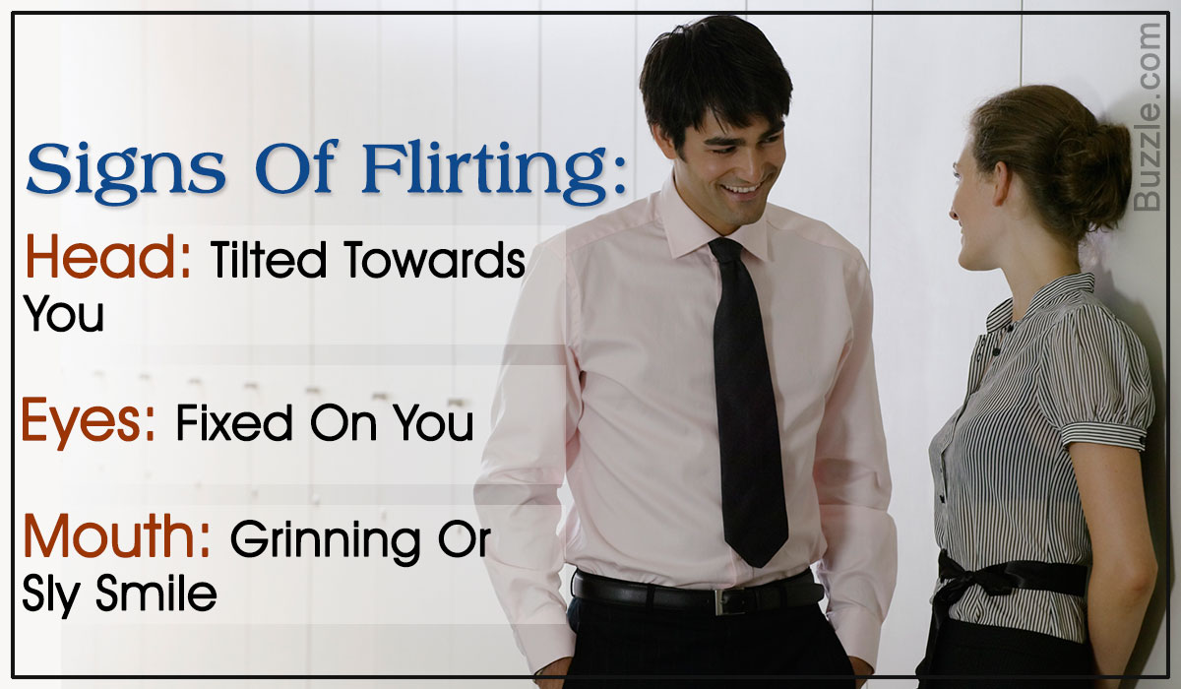
Happy / Excited

Friendly
Respectful

Negative body language
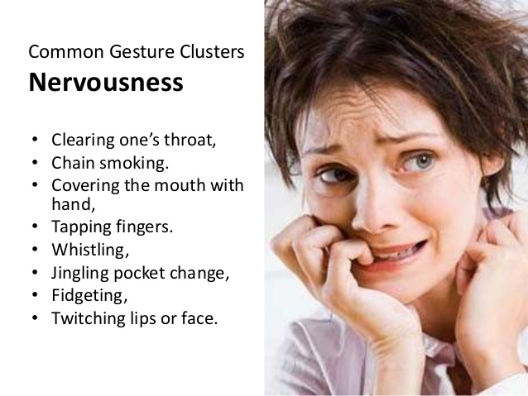
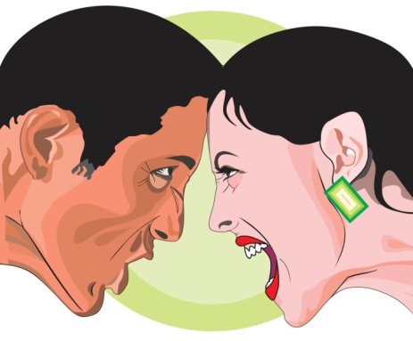


Anger

Unhappy
Sad
Hopelessness





Frustration

DATE: ____________________________ TOPIC: COMMUNICATION (WEEK 1)
___________________________________________________________________
ACTIVITY 3 WRITING & PRESENTING

Content
The learner is able to:
- Apply new knowledge to complete activity

3.1 What did you learn?
Complete the sentences, by underlining the correct word.

- Person who sends the message must be (old / clear).

- Important to understand the message, before (sending / responding) on it.

- Use (negative / positive) body language

- There is (more / less) than one way to communicate – verbal and non-verbal

- A message can (slowly / quickly) be understood wrong.

3.2 What is communication?

Fill in the correct word. Choose from the word box.

Think respond decode two-way process background information person code receiver sender

a) Communication is a ________________________________________
b) There is a _______________________(the person sending the
information) and a ________________________ (the person
receiving the information).
c) It is as if we talk in ____________________and the receiver has to _____________________ the message before he can understand it.
d) We _____________________ based on what we __________________ we have heard, our beliefs and our _____________________________
3.3 When we communicate we use the following:

__________________________

__________________________

__________________________

3.4 Name the 6 signs of positive body language.

______________________________________________________________
______________________________________________________________
______________________________________________________________
______________________________________________________________
______________________________________________________________
______________________________________________________________
DATE: ____________________________ TOPIC: COMMUNICATION (WEEK 1)
___________________________________________________________________
ACTIVITY 4 LANGUAGE STRUCTURE & CONVENTIONS

Content
The learner is able to:
- Understand and demonstrate the use of the demonstrative pronouns.

Demonstrative pronouns
Singular
We say this is when it is near. We say that is when it is far.
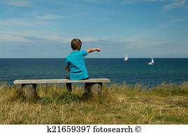


That is a boat.
This is my house.
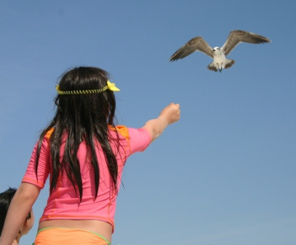
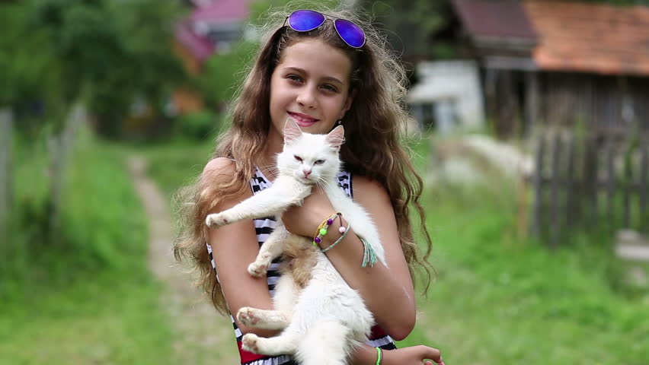

That is a bird.
This is my cat.

Plural
We say these are when they are near. We say those are when they are far.


Those are stars.
These are my cats.
Demonstrative pronouns
4.1 Singular: this and that

1. _________ is my school bag.
2. _________ car across the road is red.
3. I love _________ banana milkshake.
4. Look at __________ monkey in the tree.
5. Wash _______ spoon before you dry ________ plate.
6. _________ boy next to the tree is my brother.
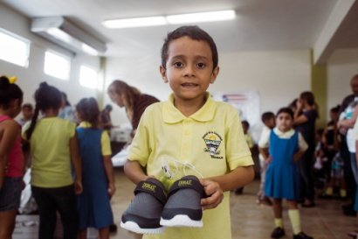
7. _________ is my new dog.
These are my new shoes.

4.2 Plural: these and those
1. ______________ are my cats.
2. At night _______________ stars look like tiny spots of light.
3. I received ________________ new shoes for my birthday.
4. ________________ birds are flying away.
5. I like _______________ pancakes.
6. _______________ learners on the playground are noisy.


Those are birds.
DATE: ____________________________ TOPIC: COMMUNICATION (WEEK 2)
___________________________________________________________________
ACTIVITY 5 LISTENING & SPEAKING

Content
The learner is able to:
- Demonstrate and mime positive and negative body language

New vocabulary.
1.Excessive | More than is necessary (Too much)  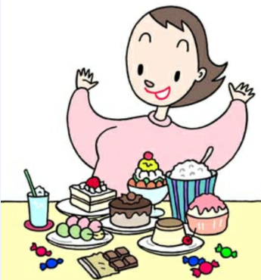
2.Nodding | Lower and raise your head slightly  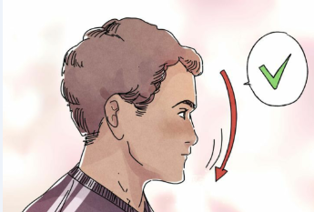
3. Fidgeting | 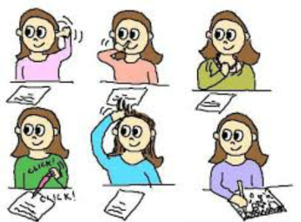
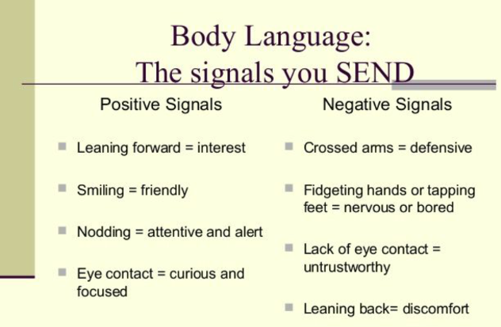

Complete the table: Body language

Positive signals |  | Negative signals
Signal | Meaning | Signal | Meaning
Leaning forward |  | Crossed arms
Smiling |  | Fidgeting
Nodding |  | Lack of  eye contact
Eye contact |  | Leaning back

DATE: ____________________________ TOPIC: COMMUNICATION (WEEK 2)
___________________________________________________________________
ACTIVITY 6 READING & VIEWING
Content
The learner is able to:
- Read individually



Going for an interview
Top 10 body language mistakes
1. Slouching

2. Breaking eye contact

3. Pointing
4. Crossed arms


5. Excessive nodding
6. Fidgeting
7. Hands behind your back
8. Mismatched expressions

9. Shifty eyes
10. Staring

Read the following paragraph out loud.
Don’t slouch during an interview! Leaning back in your chair makes you appear either lazy or arrogant. Leaning forward makes you look too eager or aggressive. It is best to sit up straight in the chair.

DATE: ____________________________ TOPIC: COMMUNICATION (WEEK 2)
___________________________________________________________________
ACTIVITY 7 WRITING & PRESENTING

Content
The learner is able to:
- Write a list

List eight body language mistakes one can make in an interview.
___________________________________________________________________________________________________________________________________________________________________________________________________________________________________________________________________________________________________________________________________________________________________________________________________________________________________________________________________________________________________________________________________________________________________________________________________________________________

DATE: ____________________________ TOPIC: COMMUNICATION (WEEK 2)
___________________________________________________________________
ACTIVITY 8 LANGUAGE STRUCTURE & CONVENTIONS
Content
The learner is able to:
- Understand and demonstrate the use of demonstrative pronouns in plural form.


- _______________ are my pencils.


- _______________are my mother’s pencils.



- _______________flowers are beautiful


- _______________flowers are dead.


- _______________apples are green.



- ________________apples are red.

DATE: ____________________________ TOPIC: COMMUNICATION (WEEK 3)
___________________________________________________________________
ACTIVITY 9 LISTENING & SPEAKING
Content
The learner is able to:
- Listen, interpret and assess demonstrations of different body languages

Body Language
First look at the demonstration of the teacher and learners having an interview and then complete the following questions by filling in true or false.

- The teacher kept her eyes focused on the learners. ___________

- The teacher’s arms were nicely (not crossed) on her lap. ___________

- The teacher kept her hands still. ___________

- The teacher walked in with her hands next to her body. ___________

- The teacher used the right facial expressions. ___________

- The teacher nodded her head when she agreed to something. _______

- The teacher sat up straight. ___________

8. Do you think the teacher is ready for an interview?
Tick the correct reason.
No, the teacher’s body language is incorrect. She must still practice.
Yes, the teacher’s body language is correct.

DATE: ____________________________ TOPIC: COMMUNICATION (WEEK 3)
___________________________________________________________________
ACTIVITY 10 READING & VIEWING / WRITING & PRESENTING
Content
The learner is able to:
- Apply shared reading on an information text.

Match the body language to the correct meaning

Body Language | Answer | Meaning
a) Brisk, erect walk |  | 1. Defensiveness
b) Standing with hands on hips |  | 2. Rejection, doubt, lying
c) Arms crossed on chest |  | 3. Anger, frustration, apprehension
d) Touching, slightly rubbing nose |  | 4. Anticipation
e) Hand to cheek |  | 5. Insecurity, nervousness
f) Hands clasped behind back |  | 6. Impatience
g) Rubbing hands |  | 7. Confidence
h) Tapping or drumming fingers |  | 8. Authoritative
i) Biting nails |  | 9. Evaluation, thinking
j) Steeping fingers |  | 10. Readiness, aggression

DATE: ____________________________ TOPIC: COMMUNICATION (WEEK 4)
___________________________________________________________________
ACTIVITY 11 LANGUAGE STRUCTURE & CONVENTIONS
Content
The learner is able to:
- Write short sentences
- Correctly use the definite and indefinite article in writing.

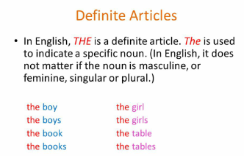
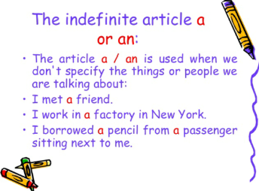
Definite article( the)
We use the when we are talking about a specific object or person.
Example: Please return the book that you borrowed from me.
Indefinite article (a / an)
We use a or an when we are not referring to a specific thing or person.
Example: I bought a cell phone yesterday.
Using a or an
We use a before a singular noun. But if it starts with a vowel (a, e, i, o, u), we use an.
Example: There is an apple in my basket.
There is a banana in my basket.

Definite article (the)
Fill in “the”
1. Please return _________book that you borrowed from me.
2. I like _______ red flowers in my garden.
3. She wore ________green dress for her interview.

Indefinite article (a and an)
Fill in ‘a’ or ‘an’
1. I brought ______ banana to school.
2. Bring ______ umbrella, it’s going to rain.
3. He needs ______ ruler in class.
4. Mother said ______apple ______ day keeps the doctor away.

DATE: ____________________________ TOPIC: COMMUNICATION (WEEK 4)
___________________________________________________________________
ACTIVITY 12 LANGUAGE STRUCTURE & CONVENTIONS
Content
The learner is able to:
- Understand when to use because and but when joining sentences.

Conjunctions
Conjunction | Examples
‘Because’ is used to show reason. | 1) I did not go swimming because it was raining.
‘Because’ is used to show reason. | 2) We could not sleep because it was too hot.
‘But’ is used to join two ideas that  are opposite. | 1) Pieter is poor but he is happy.
‘But’ is used to join two ideas that  are opposite. | 2) He fell into the drain but was not hurt.

Choose the correct conjunction and join the two sentences to make a compound sentence. Write the sentences on the lines.

Go outside and clean your feet. | because  but | She wasn’t hurt.
She fell into the drain. | because  but | Clean your shoes.
Please go outside. | because  but | They are dirty.

a) _____________________________________________________ _____________________________________________________
b) _____________________________________________________
_____________________________________________________
__________________________________________________
DATE: ____________________________ TOPIC: COMMUNICATION (WEEK 5)
___________________________________________________________________
ACTIVITY 13 LISTENING & SPEAKING
Content
The learner is able to:
- Discuss the three communication styles and apply to own life.

Three communication styles
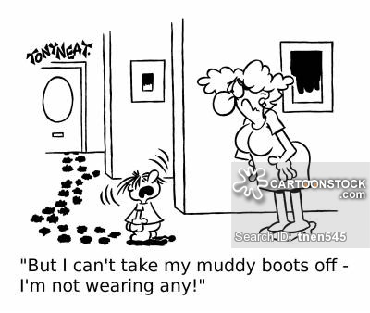
Information text
The three ego states of communication.

When we communicate we can choose to communicate from a parent, adult or child ego state.
Let me use an example to explain: Remember when your mother just cleaned the kitchen floor and you came running in with muddy feet? Your mother shouted: “Hey, you with the dirty feet, outside! Your mother was communicating from a parent state.
You felt hurt because it was not on purpose and you pushed out your lip saying: “It’s not my fault.” That was communicating from the child state.
An adult ego state is where you use logic, facts and reason to communicate. Your mother could say: “I have just washed the floor and your feet are dirty. Please go outside and clean them before you come in.” That is communicating from an adult state.

DATE: ____________________________ TOPIC: COMMUNICATION (WEEK 5)
___________________________________________________________________
ACTIVITY 14 READING & VIEWING
Content
The learner is able to:
- Apply shared reading on three communication styles

Communicating as a PARENT

- This is the communication style that you pick up from all the people who taught you in your life, for example your parents, extended family, teachers, ministers of religion and those in authority positions.

- The parent communication style is judgemental and it shows your value system. Your father may well have said: “Boys don’t cry”. So, you are uncomfortable / judgemental when you see a boy/man crying.

- Phrases used are for example: how to, always, never.

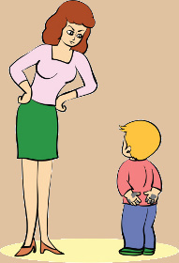

Communicating as a CHILD

- When you act like a child, for example throwing a tantrum or ignoring someone is typical.
- It can also be playful, fun and full of jokes.
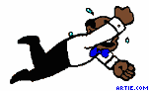
Communicating as an ADULT

- The ability to think and do for yourself, based on information that you have received. It is about direct, rational responses to the here and now.

- Phrases used are for example: “Why do you think that ____?”, “Where will you find that?” etc.

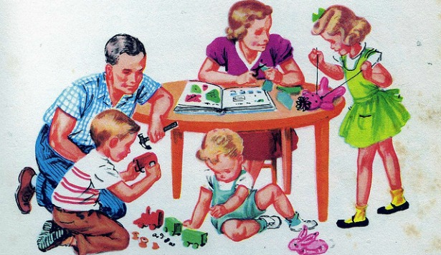

DATE: ____________________________ TOPIC: COMMUNICATION (WEEK 5)
___________________________________________________________________
ACTIVITY 15 WRITING & PRESENTING
Content
The learner is able to:
- Match the characteristics and the three communication styles.

Write the characteristics of the different communication styles.

Only write C/A/P which represents Child, Adult and Parent

COLUMN A | ANSWER: C / A / P
Reason
Playful
Condemn
Fun
Facts
Nurture
Tantrums
Logic
Manipulative
Always, never

Write the correct communication style for each of the following statements:

Only write C/A/P. It represents: Child, Adult and Parent

1 | “A client is expecting the delivery this afternoon at 15:00. Can you please make sure it is done?”
2 | “Ah shame, are you not feeling good today?”
3 | “Can we discuss this?”
4 | “You always expect me to work late!”
5 | “How many times have I told you not to be late?”
6 | “You are ignoring a colleague.”
7 | “I am unable to help you when you are interrupting me.”
8 | “Can you explain why you are late?”
9 | “You look tired, why do you not sit down?”
10 | Said in a sarcastic way: “Oh, I see you have not done your work!”
DATE: ____________________________ TOPIC: COMMUNICATION (WEEK 5)
___________________________________________________________________
ACTIVITY 16 LANGUGE STRUCTURE & CONVENTIONS
Content
The learner is able to:
- Understand and use the definite article and indefinite article.

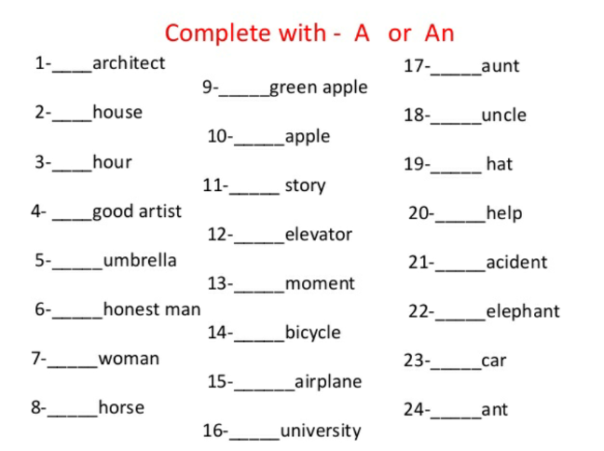
Fill in: the. a or an
1) ______ dog my father bought for me is a poodle.
2) ______ bike that Pablo bought cost him R20 000.
3) ______ movie we saw last night was very funny.
DATE: ____________________________ TOPIC: COMMUNICATION (WEEK 6)
___________________________________________________________________
ACTIVITY 17 LISTENING & SPEAKING / READING
Content
The learner is able to:
- Use polite forms of greeting on the three different levels of communication

Three levels of communication

1) Formal



When you speak to the manager of a company or when you go for an interview.
2) Informal


When you talk to friends you are more relaxed.

3) Personally

When you talk to someone whom you can share your secrets with.

DATE: ____________________________ TOPIC: COMMUNICATION (WEEK 6)
___________________________________________________________________
ACTIVITY 18 REVISION TEST
SECTION A: READING COMPREHENSION
QUESTION 1
TEXT A: INFORMATION TEXT
Read the following information about communication and answer the comprehension questions.

WHAT IS COMMUNICATION

Communication is a two way process. When we communicate, we have a sender (the person communicating) and the receiver (the person receiving the information). However, it is as if we talk in code and the receiver has to decode the message before he can understand it.
We respond based on:
- what we think we have heard
- our background and
- our beliefs.
When we communicate, words are only part (7%) of the story. We also use body language (55%) and tone of voice (38%) to communicate.

Tone of voice
Tone of voice is how we say something, compare for example:

- THIS is mine
- This IS mine
- This is MINE
Depending on how we say something, we can change the meaning of our sentence completely. Tone is very important in determining the real message.

Body Language
Body language is the way we use our bodies to communicate, for example rolling our eyes, using our hands and even the way we stand. It is important to keep our body language positive. Some examples of positive body language are:

- Making eye contact
- Keeping our hands open as opposed to clenched
- Smiling
- Standing up straight
- Leaning towards the person we are listening to
- Turning our head slightly towards the person talking.

1) Why is communication a two-way-process? (2)
_________________________________________________________________________________________________________________________________________________________________________________________________________
2) Name three things we use when communicating. (3)
_________________________________________________________________________________________________________________________________________________________________________________________________________
3) Circle the correct word in brackets. (1)
Words make up the (smallest / biggest) part of communication.
4) How would you describe the body language in the following pictures? (2)


__________________________________
__________________________________


__________________________________
__________________________________
5) Why is the tone of your voice such an important part of communication? (1)
______________________________________________________________________________________________________________________________________
6) Give one example of positive body language. (1)
______________________________________________________________________________________________________________________________________

TOTAL QUESTION 1: (10)

SECTION B: LANGUAGE
QUESTION 2
TEXT B: INFORMATION TEXT
Read the following information text about the three ego states of communication and answer the language questions.
The three ego states of communication
1. When we communicate we can choose to communicate from a parent,
2. adult or child ego state.
3. Let me use an example to explain: Remember when your mother just
4. cleaned the kitchen floor and you came running in with muddy feet?
5. Your mother shouted: “Hey, you with the dirty feet, outside! Your
6. mother was communicating from a parent state.
7. You felt hurt because it was not on purpose and you pushed out your
8. ip saying: “It’s not my fault.” That was communicating from the child
9. state. An adult ego state is where you use logic, facts and reason to
10. communicate. Your mother could say: “I have just washed the floor
11. and your feet are dirty. Please go outside and clean them before
12. you come in.” That is communicating from an adult state.

2.1) Fil in: the, a or an (3)
- We can communicate from _________ adult or ________ parent ego state.
- “Hey you with _________ dirty feet!”

2.2) Choose the correct conjunction and join the two sentences to make a compound sentence. Write the sentences on the lines.

Go outside and clean your feet. | because  but | She wasn’t hurt.
She fell into the drain. | because  but | Clean your shoes.
Please go outside. | because  but | They are dirty.

a) ____________________________________________________________ __________________________________________________________ (2)
b) ____________________________________________________________
_________________________________________________________ (2)
2.3) Find one question sentence in the information text and write it down. (1)
______________________________________________________________________________________________________________________________________
2.4) Find the compound word in line 5 and write it down. (1)
___________________________________________________________________ 2.5) Circle the correct word in brackets. (2)
- (This / That) car opposite the street belongs to (mine / me).
2.6) Find the two verbs (doing words) in line 4 and write it down. (2)
______________________________________________________________________________________________________________________________________

2.7) Rewrite the following and put in the missing capital letters and punctuation. (7)
you felt hurt because it was not on purpose and you pushed out your lip saying its not my fault

_______________________________________________________________________________________________________________________________________________________________________________________________________________________________________________________________________________________________________________________________________________

TOTAL QUESTION 2: (20÷2=10)

SECTION C: VISUAL LITERACY
QUESTION 3
3.1 Refer to the cartoon and list the three states of communication with (6) examples from the cartoon.
Hey , you with the dirty feet, outside!
It’s not my fault.

I have just washed the floor and your feet are dirty. Please go outside and clean them before you come in.

____________________________________________________________________________________________________________________________________________________________________________________________________________________________________________________________________________________________________________________________________________________________________________________________________________________________________________________________________________________________________________________________________________________________________________________________________________________________________________________________________________________________________________________________________________________________________________________________________________________________________________________________________________________________________________

3.2 Read the following cartoons and say if the situations are (4)
Assertive / Non-Assertive or Aggressive.
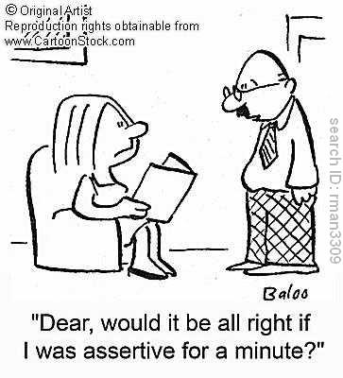
The husband is
__________________________

because he asks his wife’s permission to be assertive.

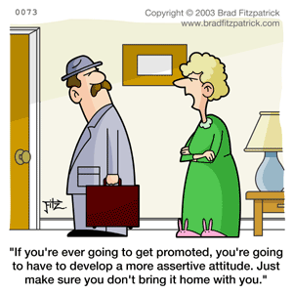
The wife is _________________________
because she gives her husband an order which clearly states that he is not OK.

The girl is
___________________________

The woman is
___________________________
because she expresses what she thinks and feel in a positive way.

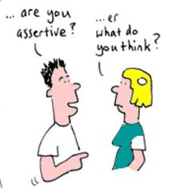

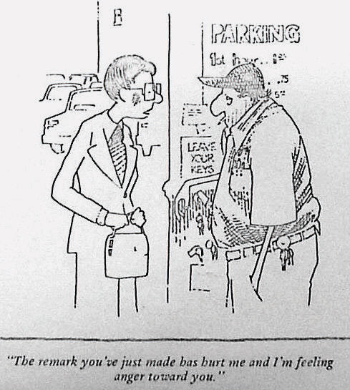

TOTAL QUESTION 3: (10)
The remark you’ve just made has hurt me and I’m feeling anger toward you.
SECTION D:
Main Idea
The main idea of a text is the most important point that the author is making about the topic / subject.

QUESTION 4
Answer the questions.

Ladybugs

Ladybugs are colourful beetles. Most
ladybugs have red wings with black spots.
Some ladybugs have orange or yellow
wings. One ladybug even has black wings
with red spots!

1) What is the topic of this text? (1)

___________________________________________________________________
2) There are lots of detail you can learn about ladybugs from reading (1) this text. What do the details tell you about ladybugs?
______________________________________________________________________________________________________________________________________
3) What’s the main idea of this text? (1) ______________________________________________________________________________________________________________________________________

4) What does the author say about most ladybugs? (1)
___________________________________________________________________
5) What does the author say about some ladybugs? (1)
___________________________________________________________________

TOTAL QUESTION 4: (5X2=10)

